JavaTM 2 Enterprise Edition

XML API for JavaTM Transactions

JSR 156

Specification Lead:
Mark Little

Technical comments:

Version 0.3
Expert Group Draft
Trademarks
Java, J2EE, Enterprise JavaBeans, JDBC, Java Naming and Directory Interface are trade-marks or registered trademarks of Sun Microsystems, Inc. in the U.S. and other countries.
Table of Contents
1. Introduction 5
1.1 Scope 6
1.2 Target Audience 6
1.3 Organization 6
1.4 Document Convention 7
1.5 J2EE Activity Service Expert Group 7
1.6 Acknowledgements 9
2. Overview 11
2.1 Problem statement 11
2.2 Pluggable transaction support 12
2.3 JAXTX components 13
3. JAXTX architecture 16
3.1 The components and their roles 17
3.1.1 The XML context 18
3.1.2 The Web service 19
3.1.3 The participant 19
3.1.4 The coordinator 19
3.2 The interfaces and protocols 20
3.2.1 Protocols 20
3.2.2 Interfaces 20
3.3 Combining implementations 21
3.4 XML configuration 21
4. JAXTX components 28
4.1 Features 28
4.1.1 Client interaction interface 28
4.1.2 Extended client interfaces 28
4.1.3 Coordinator interface 29
4.1.4 Participant interface 29
4.1.5 Context management 29
4.2 Core JAXTX packages 30
4.2.1 javax.jaxtx package 30
4.3 Transaction framework protocol 37
4.3.1 Protocol messages 38
4.3.2 More on context 40
4.3.3 Participant 41
4.3.4 Coordinator 42
4.4 Model bindings 43
4.4.1 The JTA 43
4.4.2 The Web Services Transactions Protocol 49
4.4.3 The Business Transactions Protocol 49
4.4.4 The J2EE Activity Service 53
5. References 55

Introduction
This document describes the system design and interfaces for XML based transactions. JAXTX is the realization, within the J2EE programming model, of work that has been conducted in various commercial, academic, and standards organizations into enabling Web Services with the critical transactional capabilities that they need.
An increasingly large number of distributed applications are constructed by being composed from existing applications. The resulting applications can be very complex in structure, with complex relationships between their constituent applications. Furthermore, the execution of such an application may take a long time to complete, and may contain long periods of inactivity, often due to the constituent applications requiring user interactions. In a loosely coupled environment like the Web, it is inevitable that long running applications will require support for fault-tolerance, because machines may fail or services may be moved or withdrawn. A common technique for fault-tolerance is through the use of atomic transactions, which have the well know ACID properties, operating on persistent (long-lived) objects. Transactions ensure that only consistent state changes take place despite concurrent access and failures.
Traditional transaction processing systems are sufficient if an application function can be represented as a single top-level transaction. Frequently this is not the case. Top-level transactions are most suitably viewed as “short-lived” entities, performing stable state changes to the system; they are less well suited for structuring “long-lived” application functions (e.g., running for minutes, hours, days, …). Long-lived top-level transactions may reduce the concurrency in the system to an unacceptable level by holding on to resources (e.g., locks) for a long time; further, if such a transaction aborts, much valuable work already performed could be undone.
As has been shown elsewhere [1] there are a number of transaction models, each suited to different types of applications and services. The J2EE Activity Service work of JSR 95 is intended to support the development of these models and others. However, it does not concentrate on how these implementations can be exposed as Web Services and interacted with via SOAP and XML. Alternatively, some implementations of Web Services transactions already exist, e.g., Web Services Transactions (WS-T) [2] or the OASIS Business Transactions Protocol (BTP)[3] and provide solutions for the specific problem domains. Other models will undoubtedly be developed to solve different application requirements. In addition, although ACID transactions may not be the solution for all transactional Web Service applications, it is likely that some applications will continue to require strict ACID semantics. Therefore, existing implementations of JTA/JTS may well require a Web Services persona.
The purpose of JAXTX is to identify the common components within (traditional and extended) transaction systems and provide a standard set of interfaces to these components for use within a Web Services environment. Importantly, JAXTX interfaces do not imply a specific implementation for the underlying transaction system to which they talk. This is to allow a single set of interfaces to interact with a wide range of implementations. It is the purpose of this specification to enable existing XML-based transaction implementations to be integrated with JAXTX without requiring them to be modified. However, this specification also provides optional protocol definitions to allow new implementations to be defined entirely within the context of JAXTX.
Note, in the rest of this document we shall use the term ACID transaction to refer to traditional transaction functionality as presented by, for example, JTA. The terms transaction or extended transaction, shall refer to models that give different functionality to ACID transactions, for example by relaxing various aspects of the ACID properties.

Scope
This document and related javadoc describes the architecture, functionality and interfaces that must be provided by an implementation of JAXTX in order to support XML transactions.
Specific implementations of transaction services (e.g., JTA, WS-T or BTP) will be able to use the interfaces defined by JAXTX to provide a uniform and standard API for their use.

Target Audience
The target audience of this specification includes:
- Implementers of transaction services (e.g., JTA or BTP) who wish to make their components available as Web Services.
- Implementers of application servers and EJB containers.
- Implementers of Web Services that require some level of transactionality.

Organization
This document describes the architecture of JAXTX with its components and roles described.
Specific interfaces are described in general terms in this document and in more detail in the accompanying javadoc package.

Document Convention
A regular Times New Roman font is used for describing the architecture.
A regular Courier font is used when referencing Java interfaces and methods on those interfaces.

J2EE Activity Service Expert Group
The expert group consists of the following members:
Mark Little, m.c.little@ncl.ac.uk
Station Masters House,
Ebchester,
Consett,
County Durham,
DH8 0SU,
UK
Michael Abbot, mike@codemetamorphosis.com
15 Berenda Way Suite 300,
Portola Valley, CA 94028,
USA
Rahul Bhargava, rahul_technical@yahoo.com
Netscape Communications,
MS MV-015,
465 Ellis Street,
Mtn View, CA 94043,
USA
Pyounguk Cho, pyounguk.cho@iona.com
IONA Technologies,
2350 Mission College Blvd.,
Suite 650,
Santa Clara, CA 95054,
USA
Alan Davies, adavies@seebeyond.com
SeeBeyond Technology Corporation,
404 E Huntington Drive,
Monrovia,
CA 91016,
USA
Keith Evans, keith.b.evans@hp.com
Hewlett-Packard/Compaq Computer Corporation,
CAC16-01, Room 162100,
10100 North Tantau Avenue,
Cupertino, CA 95014,
USA
Peter Furniss, peter.furniss@choreology.com
Choreology Ltd,
13 Austin Friars,
London, EC2N 2JX,
UK
Christoph Liebig, christoph.liebig@sap.com
SAP AG
Neurottstr. 16
STERN1OG
Walldorf 69190
Germany
Kavantzas Nickolaos, nkavantz@us.oracle.com
Oracle,
500 Oracle Parkway,
MS 4op9,
Redwood Shores, 94065,
USA
Bill Pope, zpope@pobox.com
PO Box 6698,
Portsmouth NH 03801,
USA
Ian Robinson, ian_robinson@uk.ibm.com
International Business Machines,
IBM Hursley Lab,
Hursley,
Winchester,
Hant, SO21 2JN,
UK
Anne Thomas, atm@systinet.com
Idoox,
1 Broadway,
14th Floor,
Cambridge, MA 02142,
USA
Peter Walker, Peter.Walker@sun.com
Sun Microsystems, Inc.
901 San Antonio Road
MS USCA14-303
Palo Alto, CA 94303

Acknowledgements

Overview
Transaction processing is at the core of commerce. All businesses have the concept of a transaction, but realize the concept using various architectures. Some transactions are very simple, such as purchasing a book or transferring funds, and can be processed immediately. Other transactions are more complex, such as fulfilling a purchase order or completing an insurance claim, and may take days or even years to process. Transaction processing forms the core of enterprise information systems and often drives the business. Once developed and proven, successful TP systems stay in place for decades.

The concepts of atomic transactions have played a cornerstone role in creating today’s enterprise application environments by providing guaranteed consistent outcome in complex multiparty business operations and a useful separation of concerns in applications. While numerous multiparty business applications involve various patterns based on atomic transactions in order to solve non-trivial business problems, it was not until recently the word “business transactions” accumulated any concrete meaning. Rapid developments in Internet infrastructure and protocols have yielded a new type of application interoperation concept that makes concepts which could only previously be considered in an abstract form an implementation reality. The effects of such changes have been felt most strongly in business environments, fuelling the mindset for a transition from traditional atomic transactions to extended transaction models better suited for Internet interoperation.
Most business-to-business applications require transactional support in order to guarantee consistent outcome and correct execution. These applications often involve long running computations, loosely coupled systems and components that do not share data, location, or administration and it is thus difficult to incorporate traditional ACID transactions within such architectures. For example, an airline reservation system may reserve a seat on a flight for an individual for a specific period of time, but if the individual does not confirm the seat within that period it will be unreserved.
Atomic transactions are a well-known technique for guaranteeing consistency in the presence of failures. The ACID properties of atomic transactions (Atomicity, Consistency, Isolation and Durability) ensure that even in complex business applications consistency of state is preserved, despite concurrent accesses and failures. This is an extremely useful fault-tolerance technique, especially when multiple, possibly remote, resources are involved.

Problem statement
As Web Services have evolved as a means to integrate processes and applications at an both inside and outside the firewall, and as Web technologies have become firmly established and widely adopted, traditional transaction semantics and protocols have proven to be inappropriate for some Web services-based applications and services. These particular Web services-based transactions differ from traditional transactions in that they execute over long periods, they require commitments to the transaction to be “negotiated” at runtime, and isolation levels have to be relaxed.
Structuring certain activities from long-running transactions can reduce the amount of concurrency within an application or (in the event of failures) require work to be performed again. For example, there are certain classes of application where it is known that resources acquired within a transaction can be released “early”, rather than having to wait until the transaction terminates; in the event of the transaction rolling back, however, certain compensation activities may be necessary to restore the system to a consistent state. Such compensation activities (which may perform forward or backward recovery) will typically be application specific, may not be necessary at all, or may be more efficiently dealt with by the application.
There have been several attempts to produce the “standard” for Web services transactions:
- Web Services transactions (WS-T) protocol: the WS-T protocol defines two transaction models – atomic transactions, which are essentially the traditional ACID transaction model to be used for short-duration tasks, and business activities, which are for long-duration tasks and allow operations to complete in their entirety and yet be undone (compensated for) later [ref].
- XAML: probably the first attempt to produce an internet based transactions protocol, this was essentially a mapping of the XA X/Open specification [ref].
- Business transaction protocol: the OASIS Business Transaction Protocol (BTP) introduced the notion of an open-top two-phase termination protocol [ref]. Work is conducted within the scope of atoms, which are similar to atomic transactions and have the same all-or-nothing guarantees. However, the outcome of atoms are controlled by cohesions which allow their selective confirmation or cancellation by explicitly driving the two-phase protocol over a period of hours, days etc.
However, it is likely that other transaction models will be required for different problem domains. There is a variety of models for Web services transactions depending on their use – 1PC, 2PC, distributed 2PC with interoperability, business process coordination. As such, it is the intention of the specification authors and supporters that other models should be added as and when they become available.

Pluggable transaction support

What does it mean for a client to begin a WS-T transaction, a JTA transaction, or a BTP transaction, for example? In many cases the answer is very little, since much of the transactionality guarantees and semantic knowledge reside within and between the services and the coordinator with which the client interacts. From a client’s perspective, differences in how extended transaction protocols are coordinated and controlled are typically minimal: the client starts the transactional activity, communicates with services (including propagation the transaction context), and terminates the transaction. Most differences occur between the transaction coordinator and its enlisted participants. For example, does it use a two-phase or three-phase termination protocol?
In a Web Services environment, the services used within an application may be selected in a number of ways; for example, based upon the transaction model(s) they support (e.g., specified in UDDI), or explicitly by the business logic. However, in a typical 3 tier architecture such as EJB, the client is typically only concerned with starting a transaction and performing work within its scope, leaving the actual transactional specific aspects to the services and the coordinator. Therefore, a single client implementation may interact with several different transaction services according to requirements placed on the application by: the services, the environment, the business needs, etc.

This specification aims to break the Web services transaction protocols into client specific APIs and server (container managed) specific APIs. Given this distinction, JAXTX will provide a generic client interface to Web services transaction protocols that allows different implementations to be plugged in. If necessary the user can introspect the underlying implementation to determine specific attributes and properties, but we believe that typically this will not be necessary. In addition, if specific models require enhanced client interfaces in order to operate, these can be obtained in a structured and well-defined manner.
Container driven APIs for the different Web service transactions protocols will also be defined, though obviously these are not generic: the server-side user (e.g., the container or EJB) must know the type of transaction it is operating within, for example in order to leverage the correct type of participant.

JAXTX components
JAXTX components allow the management in a Web services interaction of a number of activities or tasks related to an overall application. In particular JAXTX allows a user (client or service) to:
- Define demarcation points that specify the start and end points of transactional activities.
- Register participants for the activities that are associated with the application.
- Propagate transaction-specific information across the network.
The main components involved in using and defining JAXTX are illustrated in Figure 6:
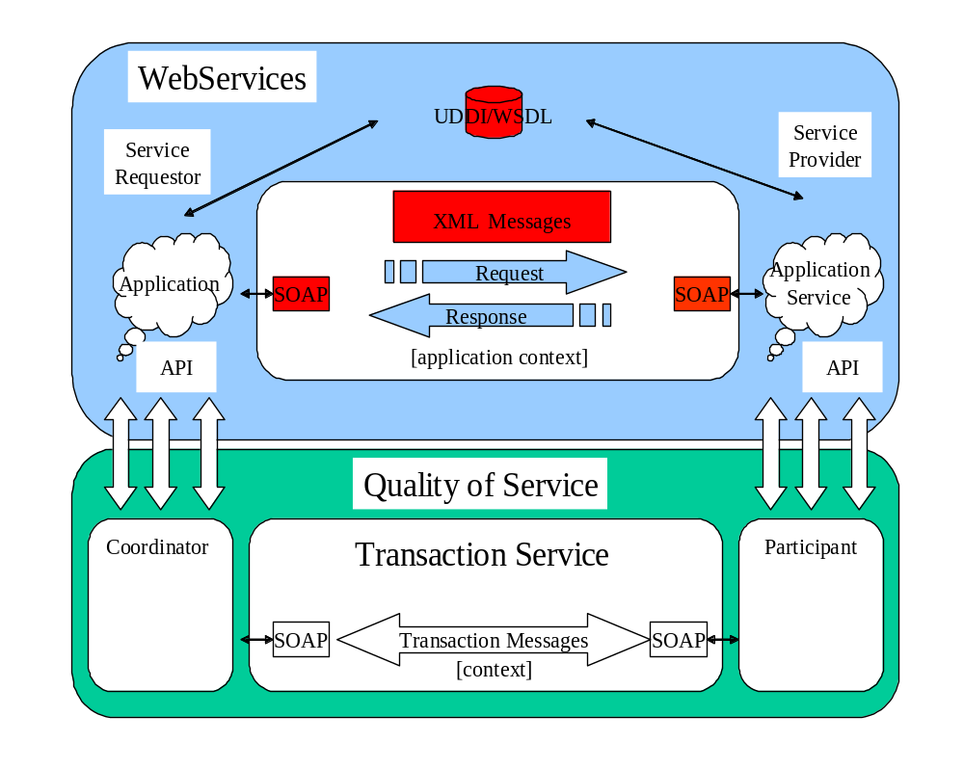
Figure 5: Web Services, transactions and contexts.

- A Transaction Service: Defines the behaviour for a specific transaction model. The Transaction Service provides a processing pattern (implemented by the transaction coordinator) that is used for outcome processing. For example, an ACID transaction service is one implementation that provides a two-phase protocol definition whose coordination sequence processing includes prepare, commit and rollback. Other examples of Transaction Service implementations include patterns such as Sagas, Collaborations, Nested or Real-Time transactions and non-transactional patterns such as Cohesions and Correlations. Multiple Transaction Service implementations may co-exist within the same application and processing domain. JAXTX does not specify how a Transaction Service is implemented: one service may be tied to a specific protocol, or the service could support multiple different protocols as in [1] or as provided through the Web Services Coordination (WS-C) specification.
- A Transaction API: Provides an interface for transaction demarcation and the registration of participants.
- A Participant: The operation or operations that are performed as part of coordination sequence processing.
- The Context: this contains information necessary for distributed services to use the transaction.

This specification it is not meant to place additional requirements on existing Web services transactions specifications (e.g., WS-T or BTP). What JAXTX does accomplish is to allow these implementations to be plugged into a common services architecture.
Note, however, that JAXTX does specify protocols for new transaction service implementations to use that will allow for their straightforward integration with this architecture.
Later sections in this specification contain protocol specific information for Java Web Services transaction implementations that do not occur in other specifications. For example, a definition of how components of the JTA specification may be incorporated into Web Services. Although these mappings are optional, we recommend that providers of JAXTX who also support implementations of these additional transaction services use these mappings.

JAXTX architecture
A transaction is a unit of (distributed) work, involving one or more parties (services, components, objects). A transaction is created, made to run, and then completed. An outcome is the result of a completed transaction and this can be used to determine subsequent flow of control to other transactions. Transactions may run over long periods of time (minutes, hours, days, …) and can thus be suspended and then resumed later.
A very high level view of the role of JAXTX within a Web Service architecture is shown in Figure 8. In keeping with the J2EE model, JAXTX divides responsibilities between application component providers who focus on writing the business logic, and product providers, who focus on providing a managed system infrastructure in which the application components are deployed.
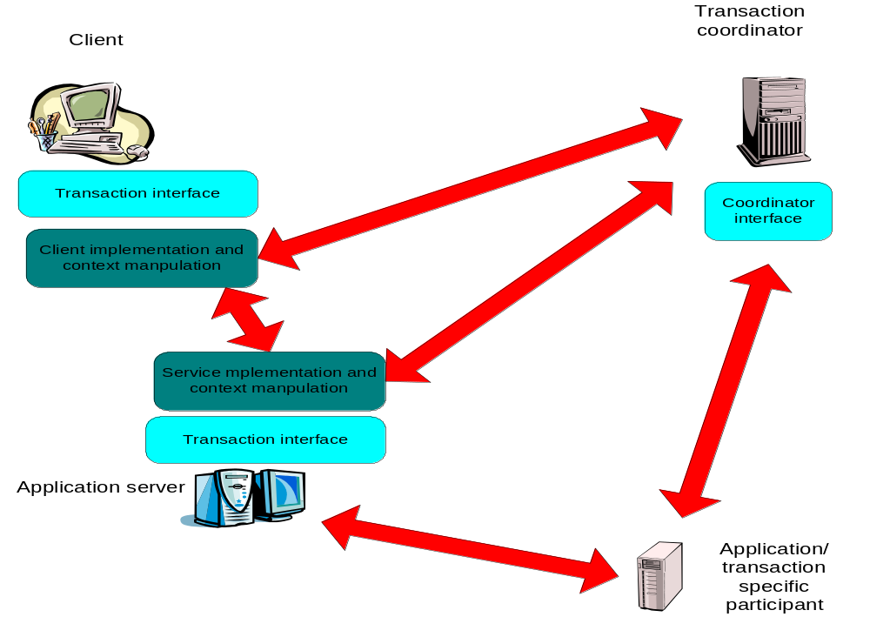
Figure 7: Applications and implementation components.
The transaction coordination service is responsible for managing transactions created by the client or container. Work done by the client may be executed under the scope of a transaction such that the coordinator will ultimately ensure that the work is performed in some manner consistent with the underlying transaction model (e.g., that it either happens or does not happen despite failures).

When a client performs an invocation on a transactional service (e.g., provided by an enterprise bean), the infrastructure in which is the client is located must flow the context to the service/container. The service (or entities it interacts with, e.g., a JDBC driver) is then responsible for ensuring that the work is performed in such a way that any final decision on the outcome is controlled by the transaction coordinator. This normally occurs by enlisting a participant in the transaction that has control over the work, e.g., a XAResource that can issue prepare, commit or rollback on an underlying database when instructed to by the coordinator.
It is envisioned that in many situations the implementation of the client/service protocol and context manipulation are provided by existing standards and systems. For example, BTP defines precisely how the transaction context appears in transmitted XML documents, how coordinator specific messages are formatted, how participants behave under certain failure circumstances etc. However, the language interfaces to these components (e.g., the coordinator interface) are typically not be defined in these specifications. JAXTX provides a uniform set of interfaces for Java that are intended to indirect to the underlying implementations.
In other circumstances, it is possible that no appropriate transaction protocol currently exists in the Web services domain. As such, one of the goals of JAXTX is to support the development of these new protocols. Therefore, this specification provides an optional protocol (including XML schemas) that designers can use in order to simplify their work and ease of integration within this framework.

The components and their roles
Before describing the interfaces which JAXTX provides, we shall first examine the components within a JAXTX architecture, as shown in Figure 9.
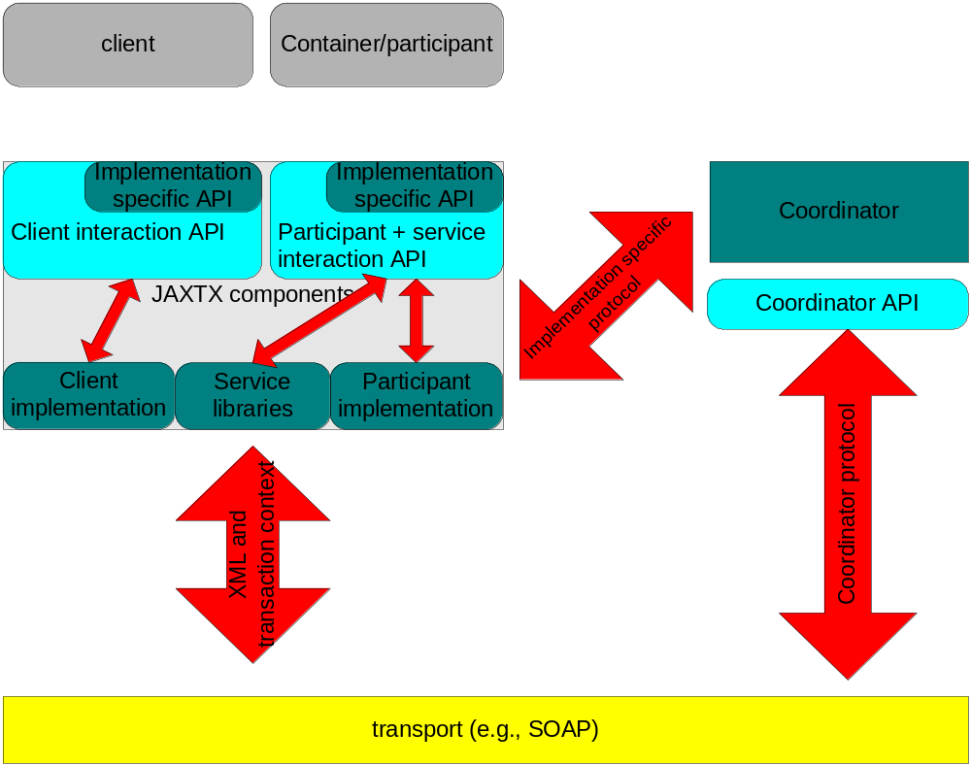
Figure 9: JAXTX architecture.

The XML context
In order for a transaction to span a distributed number of services/tasks, certain information has to flow between the sites/domains involved in the application. This is commonly referred to as the context and typically contains the following information:
The context typically includes the following information:
- A transaction identifier which guarantees global uniqueness for an individual activity (such an identifier can also be thought of as a “correlation” identifier or a value that is used to indicate that a task is part of the same work activity).
- The transaction coordinator location or endpoint address so participants can be enrolled.

- The context information is propagated to provide a flow of context information between distributed execution environments, for example using SOAP header information. This may occur transparently to the client and application services. The context may be propagated as part of normal message interchange within an application (e.g., as an additional part of the SOAP header) or may be sent as an explicit “out-of-band” context message, e.g., where the content of the message contains the context and a handle to link it to specific application messages which will be sent separately.
In those cases where existing XML-based transaction systems are being integrated into a JAXTX implementation, the context (and associated protocol) will already be defined. Rather than insist that such systems be changed to work with JAXTX, there is no mandatory context (or protocol) defined by this specification. However, for new transaction implementations that address problems not provided for by existing implementations, JAXTX does provide an optional context definition.

The Web service
The Web Service, e.g., the taxi booking service. Whenever a client contacts a service whose work it wishes to be under the control of a transaction, components of the transaction system are responsible for sending the context to that service. The service can then use this information to enlist a participant with the transaction.
Note, in the rest of this document we shall use the term container when referring to the entity that is responsible for hosting a specific service, receiving requests for it, etc. This specification does not make any assumptions about the implementation of such a container and shall attempt to talk in terms of required functionality only.

The participant
The participant is the entity that actually does the real transaction work.
The Web service contains some business logic, but it will need to
be back-ended by something that maintains information in a durable manner, e.g., a database. Although the service may talk to the back-end database directly, it cannot commit or roll back any changes it makes, since these are ultimately under the control of the transaction. In order for the transaction to be able to exercise this control, it must have some contact with the back-end resource and this is accomplished by the participant.

Each participant is tied to a specific transaction protocol (e.g., two-phase commit). However,
as with the transaction context, JAXTX provides an optional protocol definition for coordinator-participant interactions.

The coordinator
Associated with every transaction is a coordinator, which is responsible for governing the outcome of the transaction. The coordinator may be implemented as a separate service or may be co-located with the user for improved performance. It communicates with enlisted participants to inform them of the desired termination requirements. This communication will be an implementation specific protocol (e.g., two or three phase completion).
A transaction manager is typically responsible for managing coordinators for many transactions. The initiator of the transaction (e.g., the client) communicates with a transaction manager and asks it to start a new transaction and associate a coordinator with the transaction.

The interfaces and protocols

Protocols

The context and coordinator-to-participant protocol are specific to the type of transaction model provided by the implementation. If an existing XML-based transaction service implementation is being integrated with JAXTX, then they will have a format that is specified in other protocol documents, e.g., WS-T [ref] or BTP [3]. It is not the domain of this specification to impinge on these protocols and require changes to them in any way. As such, it is assumed that these relevant JAXTX component implementations will conform to these specifications.
Although it is primarily expected that JAXTX will be used to provide anAPI for existing XML transaction systems, this specification does provide an optional XML defined protocol that may be used by designers when building new Web Service transaction implementations.

Interfaces
JAXTX defines both mandatory and optional interfaces. The mandatory interfaces can be categorised as follows:
- Client: these interfaces provide clients with a uniform means by which they may access and use client-specific functionality from different transaction implementations. Typically these interfaces will be concerned with demarcating transactions.
- Implementation: the interfaces are for client-side extensions required for specific transaction models which may not be covered by the more generic client interfaces, e.g., when using the OASIS Business Transactions Protocol, it is often preferable to drive both phases of the two-phase completion protocol explicitly, whereas in a traditional transaction model the individual phases are hidden from users.
The optional interfaces are:
- Container: these interfaces provide containers with a means by which they may access service-specific functionality from different transaction implementations. For example, a service provider may be able to support multiple different transaction protocols and use different participants for each; when the transaction is imported by the container, the enterprise bean may determine the type of the transaction and enlist the right type of participant.

Combining implementations
Since we believe that there will be several different transaction implementations co-existing within the Web Services environment, it is logical to assume that some applications may require their use concurrently. As such, the JAXTX architecture does not place any limitations on the number of transaction implementations that may be utilised within a single application. Whether or not it makes sense for multiple implementations to co-exist, or how they may inter-work (assuming inter-working is required) is beyond the scope of this specification.

XML configuration
In order to select a specific transaction implementation, it is necessary to be able to define precisely the type of transaction service that is required. This must occur in an extensible manner that does not require changes to application code should the requirements or transaction definition change. As such, the use of XML is appropriate and JAXTX provides a transaction-definition schema.
Each protocol type (e.g., WS-T based) is required to be uniquely identified by a URI. In addition, each implementation of a specific transaction service may also be uniquely identified. This allows a user to select an implementation based purely on the transaction model it defines or to select on the specific implementation.

The configuration portion of the transaction schema is shown below and described in the following section. We shall see in Section 4.1.1 how instances of the schema are used within JAXTX.
<?xml version="1.0" encoding="UTF-8"?>
<xsd:schema xmlns:xsd="http://www.w3.org/2001/XMLSchema" elementFormDefault="qualified">
<xsd:element name="transaction-config">
<xsd:complexType>
<xsd:sequence>
<xsd:element name="transaction-protocol" type="xsd:anyURI" minOccurs="0" maxOccurs="1"/>
<xsd:element name="transaction-implementation" type="xsd:anyURI" minOccurs="0"/>
</xsd:sequence>
</xsd:complexType>
</xsd:element>
</xsd:schema>
JAXTX differentiates between transaction protocols (such as WS-T or BTP) and their implementations (such as may be provided by an application server vendor). When an application selects the type of transaction system to use, it must at least specify the protocol type, but may also request a specific implementation.
All protocols that are available to JAXTX must be uniquely identified using a URI. Likewise, all implementations are identified by a URI. How these URIs are maintained and what semantic information is implied by them is outside the scope of this specification. However, in the rest of this specification we shall use the following terms:
- Publish: the protocol implementation is made available to users, e.g., via UDDI or JNDI.
- Bind: the using application is tied to a specific protocol implementation via the JAXTX implementation.
When binding to a specific transaction implementation, a JAXTX compliant implementation is required to use both the transaction-protocol and transaction-implementation information to achieve an exact match based on the following rules:
- If only the transaction-protocol information is provided by the user at bind time, then the JAXTX implementation is free to bind to any corresponding transaction protocol implementation, even if the implementation has been published with a transaction-implementation.
- If both the transaction-protocol and transaction-implementation information is provided by the user at bind time, then the JAXTX implementation must only bind to a transaction service implementation that has been published with the same information.
- If only the transaction-protocol information is provided by the using application at bind time and multiple implementations are potentially available, then it is up to the specific JAXTX implementation to determine which implementation to use.

For example, if we assume we have a transaction service implementation based on the WS-T specification, the associated XML configuration is:
<?xml version="1.0" encoding="ISO-8859-1"?>
<jaxtx:transaction-config xmlns:xsi="http://www.w3.org/2001/XMLSchema-instance" xmlns:jaxtx="http://someorg.org/schemas/JAXTX.xsd">
<jaxtx:transaction-protocol>
http://www.schemas.org/. . .
</jaxtx:transaction-protocol>
</jaxtx:transaction-config>
In this configuration, the URI specifying the protocol indicates it is based on WS-T. However, there are different implementations possible for this protocol and a selecting the right one is important for interoperability. The example below shows how the transaction-implementation field can be used to specify the required variant.
<?xml version="1.0" encoding="ISO-8859-1"?>
<jaxtx:transaction-config xmlns:xsi="http://www.w3.org/2001/XMLSchema-instance" xmlns:jaxtx="http://someorg.org/schemas/JAXTX.xsd">
<jaxtx:transaction-protocol>
http://www.schemas.org/. . .
</jaxtx:transaction-protocol>
<jaxtx:transaction-implementation>
http://www.ibm.com/ws-t/atomic-transaction
</jaxtx:transaction-implementation>
</jaxtx:transaction-config>
For example, consider the deployment configuration shown in Figure 11, where there are two transaction service implementations based on WS-T: the vanilla implementation is published with only the transaction-protocol URI, whereas the implementation from txorg.com is published with the transaction-implementation URI. The client application determines the XML configuration that represents the specific transaction implementation it requires; in this particular case the JAXTX implementation then binds to the vanilla implementation.
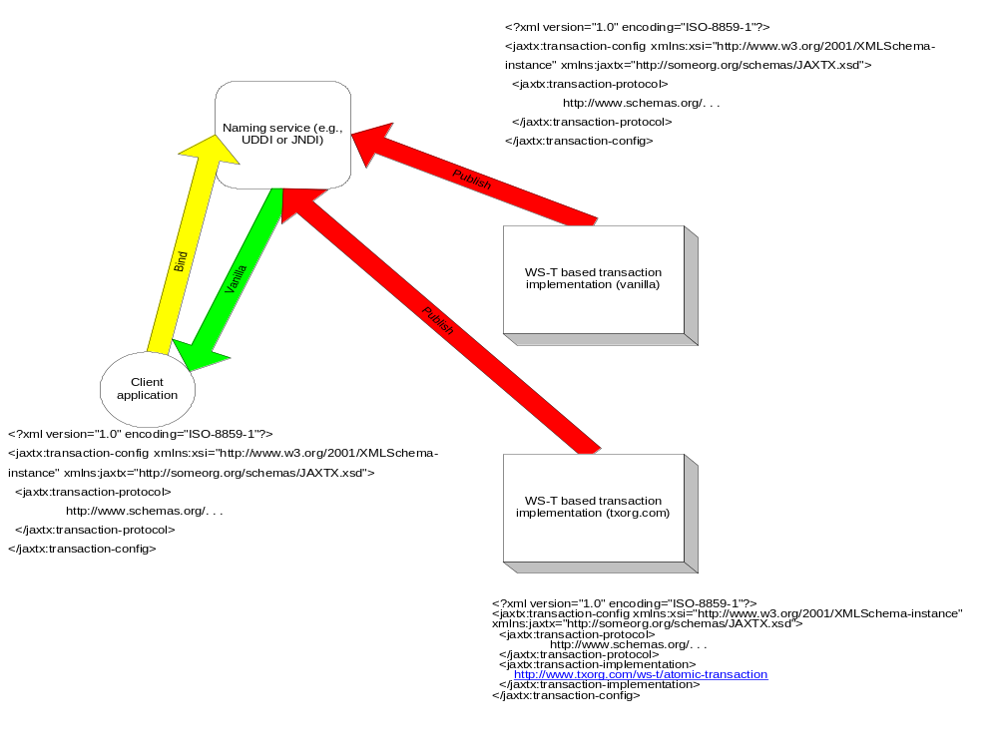
Figure 11: Binding to specific protocol.
Consider the slightly different situation shown in Figure 12: here only one transaction service implementation based on WS-T is available; the other implementation is based on BTP. As such, despite the fact that the client application does not specify transaction-implementation, the JAXTX implementation may bind it to the implementation from txorg.com.
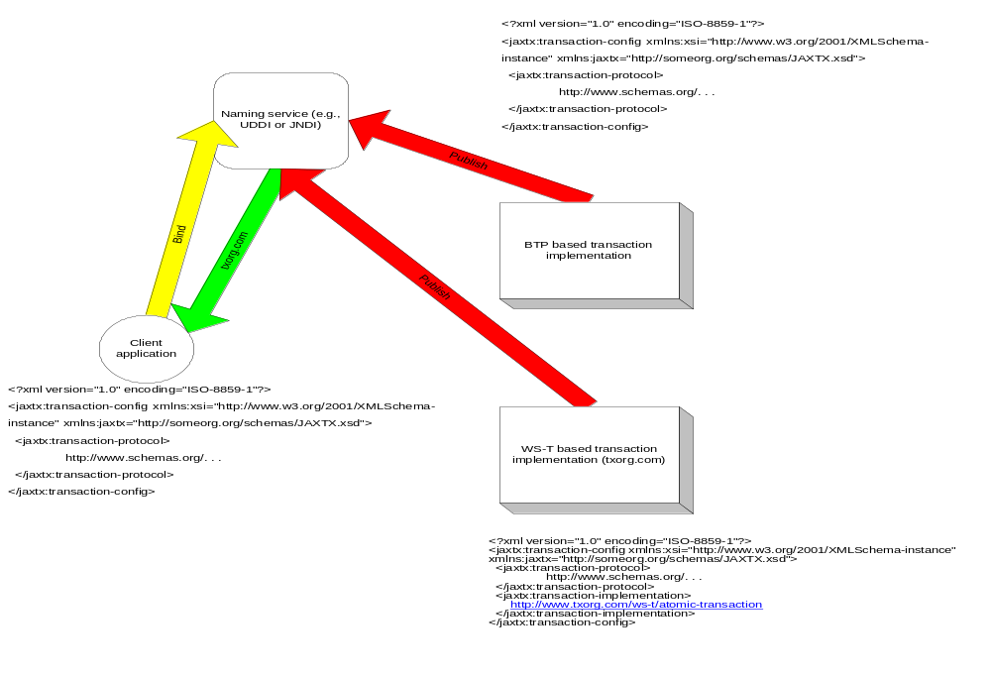
Figure 12: Binding to a non-specific implementation.
Finally, in Figure 13, the client application specifies the transaction-implementation but unfortunately although there is a WS-T implementation based on the transaction-protocol, it does not have a corresponding transaction-implementation. As such, the JAXTX implementation has no choice but to fail the bind request.
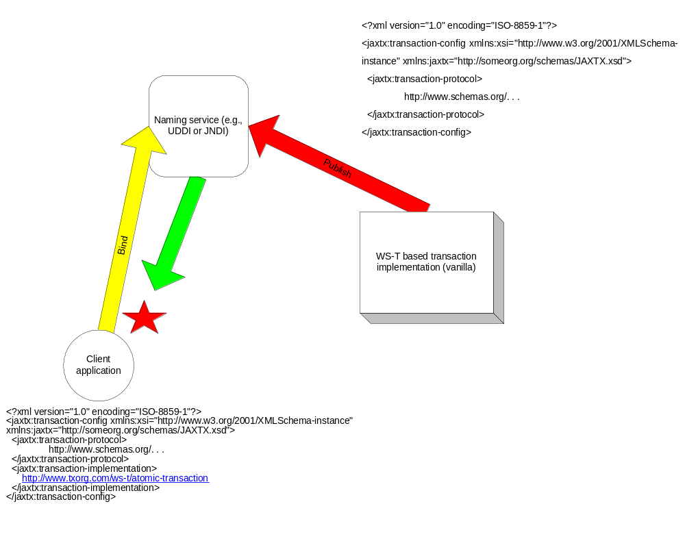
Figure 13: Binding failure.

JAXTX components

Features
The features provided by JAXTX to support the plugging of different transaction implementations within the architecture are described in this section and with reference to Figure 9. More information can be found in the associated javadoc.

Client interaction interface
Despite the variety of transaction implementations, the interfaces that most clients (and some container-side interactions) use to interact with them are very similar. These typically involve starting and ending a transaction, possibly terminating in multiple ways, e.g., commit or roll back. The UserXMLTransaction is responsible for encapsulating this common functionality within a single interface. An implementation of the UserXMLTransaction is responsible for mapping the JAXTX requirements to the underlying implementation. The UserXMLTransaction interacts with the transaction service when instructed to by the client.
The client component of an application requires some means by which the transaction context is associated with any outgoing service invocation. As described earlier, the format of the context, where it occurs within an XML invocation document etc. will be specified by the appropriate implementation. The UserXMLTransaction is required to encapsulate this context manipulation in a transparent manner to the client, such that as far as the client is concerned, the context flows implicitly with all relevant service invocations.
Note, in some transaction models, the context only flows to special transactional services (services which have identified themselves as being able to deal with transactional invocations). How these services are identified is an implementation decision and is hidden by the UserXMLTransaction.

Extended client interfaces
Some transaction implementations may require extensions to the general UserXMLTransaction interface. For example, in BTP there is scope for the client application to drive the two phase completion protocol explicitly, rather than leaving it to the transaction coordinator. Thus, there is a requirement for more than simply telling the transaction coordinator to commit the transaction.
In order to determine the properties of the underlying implementation, the UserXMLTransaction instance can return the transaction-protocol URI and, where available, the transaction-implementation URI as defined in Section 3.4.
If the client requires access to protocol specific interfaces that the implementation supports, then it can either cast the underlying implementation to a well known interface or use reflection to obtain access to the extensions.

Coordinator interface
As far as a client is concerned, the coordinator associated with a transaction is rarely seen as it is typically hidden behind interfaces such as UserXMLTransaction. However, the container or enterprise bean will eventually be required to enrol participants with the transaction in order that it can ultimately control the fate of work conducted by the bean within the scope of the transaction.
As with the client, there are some similarities as to how a service or participant interacts with a transaction coordinator. However, this generality is on a much smaller scale. Therefore, rather than provide a basic, common interface through which only some interactions with the coordinator can occur, JAXTX does not provide any mandated standard container-to-coordinator interface. Implementations are free to provide their own interfaces for services to use in order to access the necessary coordinator functionality.
To assist in the development of new Web Services transactions protocols, in Section 4.3.3 there is a Coordinator WSDL definition as part of the optional JAXTX transaction protocol.

Participant interface
Section 3.1.3 described how a participant interface is typically specific to the transaction protocol in which it will be used. The coordinator-to-participant protocol is transaction model specific and leaves little room for generality. As such, there is no mandated participant interface since its value would be minimal. Therefore, as with coordinator, the participant WSDL interface provided by JAXTX is part of the optional protocol.

Context management
thBoth the client and thcecontainer will require context manipulation functionalitytheThe context will typically be added to outgoing invocations at the client and removed at tce contaies); what is done with the context at ticecontainer-side is not specified by JAXTX, but it will typically include some mechanism for associating the work that is about to be performed by the invocation with the transaction specified in the received context.
Normally the client and container do not need to see the format (implementation) of the context: the implementation is only of concern to those entities that are responsible for manipulating and using it. However, services may need to be able to identify specific transactions or entire contexts without knowing how they are represented. For example, some transaction implementations require that only a single participant is registered for each transaction; in order to do this, a service must be able to identify the transaction currently being imported. As such, JAXTX provides interfaces to allow containers or enterprise beans to manipulate contexts at a suitably higher level.
There is no requirement for providers of transaction models to expose context management functions to clients (e.g., suspend the transaction from the current thread of control). Context management is provided to services (e.g., containers) via implementations of the XMLTransactionManager interface.
However, individual transaction implementations may extend client interfaces to provide context management explicitly. If client support for suspend/resume of a particular type of transaction context becomes a requirement for a specific transaction model, then it is the job of that transaction model to define its J2EE client architecture.

Core JAXTX packages
The JAXTX specification defines several new javax packages, described briefly in the following sections and in more detail in the associated javadoc which accompanies this specification. The javax.jaxtx package contains interfaces and classes to which all implementations of JAXTX must conform. The javax.jaxtx.model.wst, javax.jaxtx.model.as, javax.jaxtx.model.jta and javax.jaxtx.model.btp contain implementation specific enhancements for transaction models conforming to the WS-T, Activity Service, JTA and BTP specifications respectively and will be described in Section 4.4. A compliant implementation may support any combination of these models.

javax.jaxtx package
The classes and interfaces of the javax.jaxtx, javax.jaxtx.exceptions, javax.jaxtx.completionstatus and javax.jaxtx.status packages are required to abstract away from implementation specific details of the underlying transaction modelError: Reference source not found. All classes provided by implementers will conform to one or more of these interfaces. These are summarized in this section and described in full in the accompanying javadoc.

CompletionStatus
The javax.jaxtx.completionstatus.CompletionSatus interface and associated classes define the basic modes in which a transaction can terminate. Users may instruct the transaction to complete in one of these states or may set the completion status such that it will take affect when the transaction is eventually told to complete.
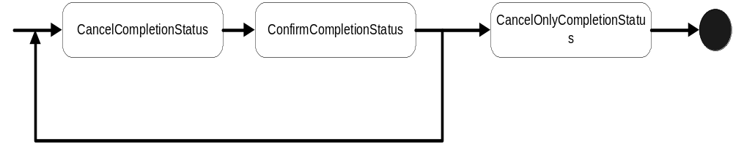
Figure 14: CompletionStatus state diagram.
As shown in Figure 14, at any time in its life a transaction will typically be in one of three completion states, such that if it is asked to complete (explicitly by the user or implicitly by virtue of failures, for example) it will do so in a manner prescribed by that state:
- ConfirmCompletionStatus: the transaction should complete in a successful state, i.e., all work performed within its scope should be accepted.. If the transaction cannot complete in this state then it will transition to the CancelCompletionStatus state.
- CancelCompletionStatus: the transaction should complete in a failure state, i.e., all work performed within its scope should be undone in an implementation specific manner. When in this state, the transaction may be transitioned into any other state. This is the default completion state in which all transactions begin.
- CancelOnlyCompletionStatus: the transaction should complete in a failure state, i.e., all work performed within its scope should be undone in an implementation specific manner. Once in this state, the transaction state cannot transition any further.
The transaction implementation will map these statuses in a model specific manner. For example, an implementation based on JTA would interpret ConfirmCompletionStatus as to commit the transaction, whereas one based on BTP would interpret it as confirm the transaction.
Note, it is possible that a specific transaction model may have additional states in which is can complete, and these may need to be available to JAXTX users. Therefore, in order to ensure extensibility and that required state transitions do not conflict, state types are required to be extensions (classes or interfaces) of the CompletionStatus interface.

Status
The state of a transaction at any point in its life is determined by the Status class and its associated implementations, as illustrated in Figure 15.
- ActiveStatus: the transaction initially starts in this state. An implementation returns this value prior to the coordinator entering a termination protocol or being marked as CancelOnlyCompletionStaus.
- MarkedCancelOnlyStatus: the transaction has been forced into a state whereby its eventual completion must be to cancel, i.e., CancelOnlyCompletionStaus.
- CompletingConfirmStatus: the transaction transitions to this state when told to complete and the completion status is ConfirmCompletionStatus. The transaction will remain in this state until it has completed in one termination outcome or another. If it cannot complete in the ConfirmCompletionStatus state then the transaction will transition to the CancelCompletionStatus state and complete. For example, in a two-phase completion protocol if the first phase (prepare) succeeds then the coordinator will commit (confirm) all state changes; if it fails then the coordinator will rollback (cancel) all state changes. If there are no failures, the transaction will typically remain in this state until it has received all responses to its termination protocol.
- CompletedConfirmStatus: the transaction has terminated successfully in the ConfirmCompletionStatus completion status. If this status is returned from a call to UserXMLTransaction.status then it is likely that errors specific to the protocol exist (e.g., heuristics); otherwise the transaction would have been destroyed and NoTransactionStatus returned.
- CompletingCancelStatus: the transaction transitions to this state when told to complete and the completion status is CancelCompletionStatus. The transaction will remain in this state until it has completed.
- CompletedCancelStatus: the transaction has terminated successfully in the CancelCompletionStatus completion status.
- NoTransactionStatus: there is no transaction associated with the invoking thread.
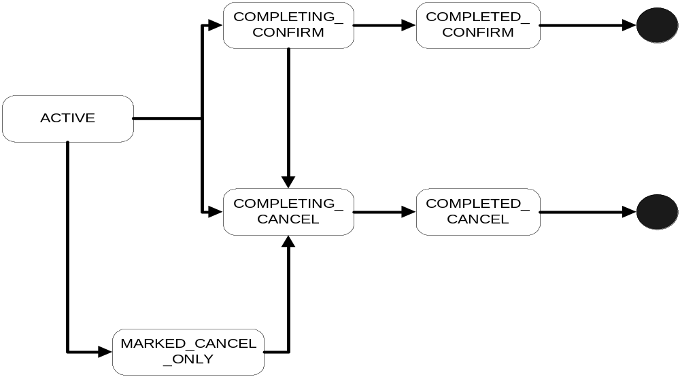
Figure 15: Transaction status transitions.
Note, it is possible that a specific transaction model may have additional states in which the transaction can be and these may need to be available to users. Therefore, in order to ensure extensibility and that required state transitions do not conflict, state types are required to be extensions of the Status interface.
The CompletionStatus and Status are closely related. Figure 15 essentially illustrates the lifecycle of a transaction, whereas Figure 14 indicates how users affect the lifecycle and force the transaction status down a specific path.

Outcome
When a user informs a transaction to terminate, the act of termination will usually return information about how the transaction completed. This information may be present both for successful and unsuccessful termination of a transaction. For example, in an implementation of the JTA protocol for Web services, the ConfirmCompletionStatus state for a transaction would correspond to committing the transaction; a successful outcome would result in no exceptions being generated. However, an unsuccessful termination, for example because of participant failures, could return a specific heuristic exception.
In order to support the different transaction model requirements for return types, UserXMLTransaction is required to return an instance of classes derived from the Outcome interface. The types of Outcome and their internal encodings are required to be specified by the definer/implementer of the transaction implementation.

TxContext
Fundamental to the JAXTX architecture is the notion of a transaction context. Each thread is associated with a contexn. This association may be null, indicating that the thread has no associated transaction, or it refers to a specific transaction.d.

Users of JAXTX (clients or containers) will require the ability to identify specific transactions or to suspend/resume a transaction from a thread of control. Implementations of TxContext represent of a transaction (or stack of transactions). The implementation of the interface can be as lightweight as required by the underlying transaction implementation in order that it can uniquely represent all associated transaction instances.

UserXMLTransaction
The UserXMLTransaction is the interface that most users (e.g., clients and containers) will see. This isolates them from underlying protocol specific aspects of the transaction implementation. If required, an underlying implementation may provide additional methods to users, who may cast or reflect to the underlying implementation if necessary. Importantly, a UserXMLTransaction does not represent a specific transaction, but rather is responsible for providing access to an implicit per-thread transaction context. Therefore, all of the UserXMLTransaction methods implicitly act on the current thread of control.
A new transaction is begun and associated with the invoking thread by using the start method. If nested transactions are supported by the transaction service implementation, then a transaction that is already associated with the invoking thread will become the parent of this newly created transaction, i.e., the new child transaction is nested within the parent. If nesting is not supported then the javax.jaxtx.exceptions.NestingNotAllowedException is thrown. The state of the parent transaction may be such that it is invalid for a new transaction to be created within its scope (e.g., the parent is in the process of terminating) and in this situation the javax.jaxtx.exceptions.InvalidStateException is thrown.
The setTimeout method modifies a state variable associated with the UserXMLTransaction that affects the time-out period in seconds associated with the transaction created by subsequent invocations of the start method. If the parameter has a non-zero value and the transaction has not begun to terminate before this time period has elapsed, it will be completed in the CancelCompletionStatus mode. If the timeout period is invalid in the scope of the transaction service implementation, then the javax.jaxtx.exceptions.InvalidTimeoutException is thrown. A value of zero means that no application specified time-out is established. This is the default value associated with all threads.
The getTimeout method returns the timeout value currently associated with the UserXMLTransaction.
The state in which the current transaction should be completed is set using the setCompletionStatus method. If the completion state is invalid given the state of the transaction (e.g., it has already begun to complete) then the javax.jaxtx.exceptions.InvalidStateException will be thrown. The completion status of the transaction currently associated with the invoking thread can be obtained from the getCompletionStatus method. As shown in Figure 14, if there has been no call to the setCompletionStatus then the default completion status is CancelCompletionStatus. If there is no transaction associated with the current thread then the javax.jaxtx.exceptions.NoTransactionException is throws.
A transaction can be told to complete using the end method; this will also disassociate the thread from the transaction before it returns. The completion status the transaction implementation uses will either have been set by a previous call to setCompletionStatus, may be provided as a parameter to end, or will be the default of CancelCompletionStatus. If this is a top-level transaction, i.e., it has no parent, then upon completion the thread will have no transaction associated with it. Alternatively, it will be set to the parent of the just completed transaction. If no transaction is associated with the current thread then the javax.jaxtx.exceptions.NoTransactionException is thrown.
Some transaction models may restrict the ability for threads to end transactions, e.g., such that only the transaction creator may terminate the transaction. If this is the case, the implementation must throw the javax.jaxtx.exceptions.NoPermissionException. If the specified completion state of the transaction is not compatible with the transaction’s state (for example, its completion state is CancelOnlyCompletionStatus and the user has asked the transaction to terminate with a status of ConfirmCompletionStatus), or the state of the transaction does not allow it to be terminated, then the javax.jaxtx.exceptions.InvalidStateException will be thrown.
Obviously a transaction may not be able to complete in the state originally requested by the user. When the transaction terminates it may return an Outcome object to indicate how it did complete. It is up to the transaction service implementation to determine whether it is valid for end to return a null Outcome. A transaction that completes and returns neither an Outcome nor throws an exception is assumed to have completed in the manner requested.

The current status of the transaction is returned by the status method. If there is no transaction associated with the thread then NoTransactionStatus is returned. If the exact determination of a transaction’s status is not possible when status is invoked, UnknownStatus is returned. This is a transient value and calling status again will eventually return a definitive answer.
Every transaction is required to have a unique identity, which can be obtained from the globalIdentity method. However, in order to ensure that transaction identifiers are unique across all transaction models, the value returned by globalIdentity is required to be prefixed with the package name of the transaction implementation. For example, “javax.jaxtx.model.jta.1234” or “javax.jaxtx.model.as.1234”. If there is no transaction associated with the current thread then null will be returned.
In addition to globalIdentity, the transactionName method can be used to obtain a more user-friendly representation of the transaction. This may return the same as globalIdentity or more return other information more suitable for debugging purposes, for example. If there is no transaction associated with the current thread then null will be returned.

UserXMLTransactionFactory
UserXMLTransactions are obtained from a UserXMLTransactionFactory, which is made available via JNDI lookup of java:comp/UserXMLTransactionFactory. The UserXMLTransaction corresponding to the specific transaction type is returned from the factory’s getTransactionType method, as defined in the associated XML document configuration. If no such transaction type is provided by the factory, then the javax.jaxtx.exceptions.NoSuchServiceException is thrown; a deployment domain is free to restrict the availability of an implementation and in which case it will throw the javax.jaxtx.exceptions.InvalidTransactionDomainException.
The getTransactionContext method returns the TxContext for the current transaction, or null if there is none associated with the invoking thread. Unlike suspend, this method does not disassociate the current thread from the transaction(s). This can be used to enable multiple threads to execute within the scope of the same transaction.

XMLTransactionManager
The XMLTransactionManager is the basic container/bean programming interface. As with UserXMLTransaction, this interface isolates services from underlying protocol specific aspects of the transaction implementation they are using. A XMLTransactionManager does not represent a specific transaction, but rather is responsible for providing access to an implicit per-thread transaction context. Therefore, all of the XMLTransactionManager methods implicitly act on the current thread of control.
A thread of control may require periods of non-transactionality in order for it to perform work that is not associated with a specific transaction. In order to do this it is necessary to disassociate the thread from any transactions. The suspend method accomplishes this, returning a TxContext instance, which is a handle on the transaction context. If the current transaction is nested, then the TxContext will implicitly represent the stack of transactions up to and including the root transaction. The thread then becomes associated with no transaction.
The resume method can be used to (re-)associate a thread with a transaction(s) via its TxContext. Prior to association, the thread is disassociated from any transaction(s) with which it may be currently associated. If the TxContext is null, then the thread is associated with no transaction. The javax.jaxtx.exceptionsInvalidTransactionException is thrown if the transaction that the TxContext refers to is invalid in the scope of the invoking thread. It is up to the underlying transaction implementation to determine the validity of a specific context.

XMLTransactionManagerFactory
XMLTransactionManagers are obtained from a XMLTransactionManagerFactory, which is made available via JNDI lookup of java:comp/XMLTransactionManagerFactory. The XMLTransactionManager corresponding to the specific transaction type is returned from the factory’s getTransactionType method, as defined in the associated XML document configuration. If no such transaction type is provided by the factory, or the deployment domain does not support the implementation, then the javax.jaxtx.exceptions.NoSuchServiceException is thrown; a deployment domain is free to restrict the availability of an implementation and in which case it will throw the javax.jaxtx.exceptions.InvalidTransactionDomainException.
In the situation of a container importing a transaction, the XMLTransactionManager associated with the current thread is returned by the currentXMLTransactionManager. If there is no transaction associated with the thread then null is returned.

Transaction framework protocol
Before describing the client and container interfaces, in this section we shall examine the optional XML protocol that JAXTX provides (JAXTXP), which is primarily intended for new transaction service implementations.

Each extended transaction protocol is designed to target a specific problem area, e.g., relaxing atomicity or allowing controlled un-serialisable behaviour. Therefore, rather than specify an XML-based transaction protocol that is aimed at solving a single problem, JAXTXP is meant to allow arbitrary transaction implementations to utilise it. The goals of this protocol are therefore to:
- Provide a basic definition of a core transaction service consisting of a Coordinator Service.
- Define the required infrastructure support, such as event mechanisms, etc.
- Define the roles and responsibilities of subcomponents.
The main components involved in using and defining the protocol are:
- A Coordination Service: defines the behaviour of a specific transaction model and provides a processing pattern that is used for outcome determination. For example, a two-phase ACID transaction service is one implementation whose processing sequence includes prepare, commit and rollback. Other implementation examples include Sagas, Collaborations and Real-Time transactions.

- The context: this contains information necessary to perform coordination as well as information specific to the Coordination Service.

Protocol messages
In Section 2 we saw the relationship between the transaction coordinator and participants. This relationship exists irrespective of the type of transaction protocol that is being used: at some point (or points) during the lifetime of the transaction, the coordinator will be required to communicate with the participants. This is a bi-directional relationship, such that a service or participant may also be required to communicate with the coordinator.
For example, the termination of one activity may initiate the start/restart of other activities in a workflow-like environment. Messages can be used to infer a flow of control during the execution of an application. The information encoded within a message will depend upon the implementation of the extended transaction model.
A participant will use the message in a manner specific to the transaction implementation and return a result of it having done so. For example, upon receipt of a specific message, a participant could start another transaction running (e.g., a compensation transaction); another participant could commit any modifications to a database when it receives one type of message, or undo them if it receives another type.
JAXTXP does not require that communication between coordinator and participant be synchronous or based on any request/response pattern. Message exchanges may occur in an RPC approach if deemed necessary by the transaction implementation, or it may use more asynchronous, message-oriented approaches. As a result, a participant may send responses to coordinator messages that have not yet been (and potentially may never be) produced, e.g., a two-phase participant may be able to autonomously prepare itself and signal this fact to the coordinator, even though the coordinator may never be asked to commit.
In addition, as we shall see in Section 4.3.2, unlike traditional ACID two-phase protocols, where a user’s (direct or indirect) interaction with the coordinator signals the end of the transaction, this is not an assumption JAXTXP makes: coordinator interactions may occur at many times during the lifetime of an extended transaction; termination of the transaction upon completing a coordination interaction is an implementation decision.
<xsd:element name="protocol_message" substitutionGroup="message">
<xsd:complexType>
<xsd:sequence>
<xsd:element name="specific_data" type="xsd:anyType" minOccurs="0" maxOccurs="unbounded"/>
<xsd:elememt ref=”qualifiers” minOccurs=”0”/>
</xsd:sequence>
<xsd:attribute name="identification" type="xsd:anyURI" use="required"/>
<xsd:attribute name="related_to" type="xsd:anyURI" use="optional"/>
</xsd:complexType>
</xsd:element>
- identification: this is the unique identification of this message and will be interpreted by the receiver in a protocol specific manner. For example, the two-phase commit transaction identified by the “urn:twophase” may define protocol messages “urn:twophase:prepare”, “urn:twophase:commit” and “urn:twophase:rollback”, which would be interpreted by receivers as either preparing, committing or rolling back the transaction accordingly. Their responses may be “urn:twophase:readonly”, “urn:twophase:ok” and “urn:twophase:fail”.
- specific_data: additional protocol-specific information may be present in this field.
- qualifiers: any qualifiers necessary for the interpretation of this message are specified in this field.
- related_to: JAXTXP does not require that coordinator-to-participant interactions be synchronous and driven by the coordinator. As such, it is entirely possible that a participant may autonomously decide to send the coordinator a message to indicate its current state in the protocol. For example, a two-phase aware participant may be able to spontaneously prepare and send the result to the coordinator, on the assumption that the coordinator will eventually send it a prepare message. If the participant does, however, it is important that it also specify which message it assumed the coordinator would generate in order for it to send that response: if the coordinator does not eventually send that message then obviously the response from the participant is in error. As such, the related_to field is required to be present for all spontaneously generated participant responses and indicates the relevant coordinator protocol message. It is optional in all other message interactions.

More on context
The context information is propagated using SOAP messages, and is correlated to the application messages using unique identifiers in the SOAP header. The context may be propagated as part of normal message interchange within an application (e.g., as an additional part of the SOAP header) or may be sent as an explicit “out-of-band” context message, e.g., where the content of the message contains the context and a handle to link it to specific application messages which will be sent separately. Context propagation may also occur using different protocols than those used by the application. Therefore, JAXTXP does not assume a specific means by which contexts are propagated, leaving this up to the specific coordination service implementation.
<xsd:element name="contextelement">
<xsd:annotation>
<xsd:documentation>
contextelement represents the information for an entry in the hierarchy.
</xsd:documentation>
</xsd:annotation>
<xsd:complexType>
<xsd:attribute name="transaction-name" type="xsd:anyURI" use="optional"/>
<xsd:attribute name="coordinator" type="Coordinator" use="required"/>
<xsd:attribute name="ctxId" type="xsd:anyURI" use="required"/>
<xsd:attribute name="timeout" type="xsd:integer" use="optional"/>
<xsd:attribute name="implementation_specific_data" type="xsd:anyType" use="optional"/>
<xsd:sequence>
<xsd:element ref="qualifiers" minOccurs="0"/>
</xsd:sequence>
</xsd:complexType>
</xsd:element>
<xsd:element name="context" substitutionGroup="message">
<xsd:annotation>
<xsd:documentation>
context represents the context hierarchy.
</xsd:documentation>
</xsd:annotation>
<xsd:complexType>
<xsd:sequence>
<xsd:element ref="contextelement"/>
</xsd:sequence>
<xsd:attribute name="invocation_specific_data" type="xsd:anyType" use="optional"/>
</xsd:complexType>
</xsd:element>
In order to support nesting of transactions, the context is an arbitrary length sequence of contextelement data structures, where the first element in the list is the root transaction and the last is the current transaction. The data encoded within this structure is:
- transaction-name: an optional unique name for this transaction, this field may be used to identify the type of transaction being imported.
- coordinator: a reference to the coordinator responsible for this specific transaction. See Section 4.3.2 for more information about the coordinator.
- ctxId: a unique identifier for this transaction.
- timeout: some transaction implementations allow a timeout value (typically measured in seconds) to be associated with a transaction, such that, if the transaction has not been completed when this time elapses, it will be automatically terminated.
- implementation_specific_data: any additional information which may be required by the specific transaction implementation being used. How this is identified and interpreted is outside the scope of this specification.
- qualifiers: additional qualifiers that may be required to further interpret the information contained within the context.

Coordinator
To drive the message exchanges a coordinator is associated with each transaction. Activities that require to be informed when coordinator sends a specific message can register a participant with that coordinator. When a message is sent by the coordinator (e.g., at termination time), it may result in a response being returned by the recipient (participant). Alternatively, depending upon the protocol in use, no such message may be forthcoming. As such, the coordinator-participant interaction is not required to be synchronous and follows a more asynchronous, message-oriented pattern. Obviously RPC-based (synchronous) invocations may be layered on top of this.
In a traditional ACID transaction system, the two-phase protocol is only executed by the coordinator when the transaction terminates. Once the second phase has completed successfully, the transaction and associated coordinator are terminated. However, there are several extended transaction models that allow coordination to occur at times during the lifetime of the transaction (e.g., Split Transactions). Therefore, the JAXTX coordinator can be driven at arbitrary points.
The implementation of the coordinator will obviously depend upon the type of extended transaction model being used. For example, if a Sagas type model is in use then a compensation message may be required to be sent to participants if a failure has happened, whereas a coordinator for a strict transactional model may require to send a message informing participants to rollback.

Model bindings
In the following sections we shall examine how specific transaction models may be mapped into a JAXTX environment. These models may define new client-side interfaces and optional service-side interfaces as well as make use of the JAXTXP.

The JTA
In this section we shall consider how to use the JTA transaction model within a Web Services environment. This involves specifying optional interfaces over and above those defined by core JAXTX. This implementation uses and enhances JAXTXP.
Note, the interfaces described in this section occur within the javax.jaxtx.model.jta.opt package.

XML configuration
The configuration information required to be associated with an implementation of the JTA interfaces defined in this section is shown below:
<?xml version="1.0" encoding="ISO-8859-1"?>
<jaxtx:transaction-config xmlns:xsi="http://www.w3.org/2001/XMLSchema-instance" xmlns:jaxtx="JAXTX.xsd">
<jaxtx:tx-info>
<jaxtx:transaction-name>
urn:com:sun:jaxtx:transaction_models:jta:1.0.1
</jaxtx:transaction-name>
</jaxtx:tx-info>
</jaxtx:transaction-config>

Client-side interfaces
The standard client-side interface of javax.jaxtx.UserXMLTransaction is sufficient to demarcate JTA transaction boundaries, with the following mappings:
JTA | JAXTX JTA equivalent
UserXMLTransaction/XMLTransactionManager.begin | UserXMLTransaction.start
javax.transaction.NotSupportedException | javax.jaxtx.exceptions.NestingNotAllowedException
UserXMLTransaction/XMLTransactionManager/Transaction.commit | CompletionStatusConfirm and UserXMLTransaction.end. Successful commitment returns an Outcome with the name “javax.jaxtx.model.jta.commit” and completedStatus of CompletionStatusConfirm.
javax.transaction.RollbackException | UserXMLTransaction.end returns an Outcome with the name “javax.jaxtx.model.jta.rolledback” and completedStatus of CompletionStatusCancel
javax.transaction.HeuristicMixedException | javax.jaxtx.exceptions.HeuristicMixedException
javax.transaction.HeuristicHazardException | javax.jaxtx.exceptions.HeuristicHazardException
UserXMLTransaction/XMLTransactionManager/Transaction.rollback | CompletionStatusCancel or CompletionStatusCancelOnly and UserXMLTransaction.end. Successful rollback returns an Outcome with the name “javax.jaxtx.model.jta.rollback” and completedStatus of CompletionStatusCancel.
UserXMLTransaction/XMLTransactionManager/Transaction.setRollbackOnly | UserXMLTransaction.setCompletionStatus with CompletionStatusCancelOnly
javax.transaction.Status.STATUS_PREPARED | javax.jaxtx.model.jta.PreparedStatus

Service-side interfaces
The JTA defines two types of participant:
- XAResource: this is a Java mapping of the industry standard XA resource manager interface [4].
- Synchronization: the transaction manager provides a synchronization protocol that allows the interested party to be notified before and after the transaction completes.
Rather than define new Web Services equivalent interfaces, JAXTX continues to use these interfaces in order to leverage existing implementations. However, because JAXTXP is being used, an implementation of the Participant interface is required to be the Web Services persona of the JTA implementations.
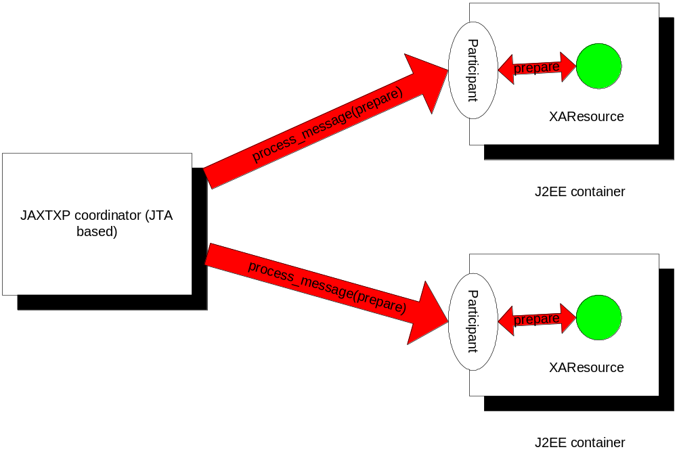
Figure 18: JTA and JAXTXP protocol interoperation.

Services can enrol participants (XAResource or Synchronization instances) through the XMLTransactionManager interface, which returns a reference to the current transaction (instance of javax.jaxtx.model.jta.opt.Transaction) via the getTransaction method. The Transaction interface provides a means whereby participants of either type may be enrolled with a specific transaction. Unlike UserXMLTransaction, a Transaction does represent a specific transaction instance.

JAXTXP specifics
The JTA protocol is mapped into JAXTXP with the following protocol messages:

<?xml version="1.0" encoding="ISO-8859-1"?>
<jaxtx:jta_message_set
xmlns:xsi=http://www.w3.org/2001/XMLSchema-instance
xmlns:jaxtx="JAXTX.xsd">
<jaxtx:protocol_message>
<jaxtx:identification> urn:com:sun:jaxtx:transaction_models:jta:1.0.1:before_completion
</jaxtx:identification>
<jaxtx:specific_data>
<xsd:element name="tranID" type="xsd:anyURI" use="required"/>
</jaxtx:specific_data>
</jaxtx:protocol_message>
<jaxtx:protocol_message>
<jaxtx:identification>
urn:com:sun:jaxtx:transaction_models:jta:1.0.1:after_completion </jaxtx:identification>
<jaxtx:specific_data>
<xsd:element name="tranID" type="xsd:anyURI" use="required"/>
</jaxtx:specific_data>
<jaxtx:specific_data>
<xsd:element name="status" type="jaxtx:status" use="required"/>
</jaxtx:specific_data>
</jaxtx:protocol_message>
<jaxtx:protocol_message>
<jaxtx:identification>
urn:com:sun:jaxtx:transaction_models:jta:1.0.1:commit
</jaxtx:identification>
<jaxtx:specific_data>
<xsd:element name="tranID" type="xsd:anyURI" use="required"/>
</jaxtx:specific_data>
<jaxtx:specific_data>
<xsd:element name="onePhase" type="xsd:boolean" use="required"/>
</jaxtx:specific_data>
</jaxtx:protocol_message>
<jaxtx:protocol_message>
<jaxtx:identification>
urn:com:sun:jaxtx:transaction_models:jta:1.0.1:start
</jaxtx:identification>
<jaxtx:specific_data>
<xsd:element name="tranID" type="xsd:anyURI" use="required"/>
</jaxtx:specific_data>
<jaxtx:specific_data>
<xsd:element name="flags" type="xsd:integer" use="required"/>
</jaxtx:specific_data>
</jaxtx:protocol_message>
<jaxtx:protocol_message>
<jaxtx:identification>
urn:com:sun:jaxtx:transaction_models:jta:1.0.1:end
</jaxtx:identification>
<jaxtx:specific_data>
<xsd:element name="tranID" type="xsd:anyURI" use="required"/>
</jaxtx:specific_data>
<jaxtx:specific_data>
<xsd:element name="flags" type="xsd:integer" use="required"/>
</jaxtx:specific_data>
</jaxtx:protocol_message>
<jaxtx:protocol_message>
<jaxtx:identification>
urn:com:sun:jaxtx:transaction_models:jta:1.0.1:forget
</jaxtx:identification>
<jaxtx:specific_data>
<xsd:element name="tranID" type="xsd:anyURI" use="required"/>
</jaxtx:specific_data>
</jaxtx:protocol_message>
<jaxtx:protocol_message>
<jaxtx:identification>
urn:com:sun:jaxtx:transaction_models:jta:1.0.1:isSameRM
</jaxtx:identification>
<jaxtx:specific_data>
<xsd:element name="xares" type="xsd:anyURI" use="required"/>
</jaxtx:specific_data>
</jaxtx:protocol_message>
<jaxtx:protocol_message>
<jaxtx:identification>
urn:com:sun:jaxtx:transaction_models:jta:1.0.1:isSameRM_response
</jaxtx:identification>
<jaxtx:specific_data>
<xsd:element name="isSameRM" type="xsd:boolean" use="required"/>
</jaxtx:specific_data>
</jaxtx:protocol_message>
<jaxtx:protocol_message>
<jaxtx:identification>
urn:com:sun:jaxtx:transaction_models:jta:1.0.1:prepare
</jaxtx:identification>
<jaxtx:specific_data>
<xsd:element name="tranID" type="xsd:anyURI" use="required"/>
</jaxtx:specific_data>
</jaxtx:protocol_message>
<jaxtx:protocol_message>
<jaxtx:identification> urn:com:sun:jaxtx:transaction_models:jta:1.0.1:prepare_response
</jaxtx:identification>
<jaxtx:specific_data>
<xsd:element name="prepare" type="xsd:integer" use="required"/>
</jaxtx:specific_data>
</jaxtx:protocol_message>
<jaxtx:protocol_message>
<jaxtx:identification>
urn:com:sun:jaxtx:transaction_models:jta:1.0.1:recover
</jaxtx:identification>
<jaxtx:specific_data>
<xsd:element name="flag" type="xsd:integer" use="required"/>
</jaxtx:specific_data>
</jaxtx:protocol_message>
<jaxtx:protocol_message>
<jaxtx:identification> urn:com:sun:jaxtx:transaction_models:jta:1.0.1:recover_response
</jaxtx:identification>
<jaxtx:specific_data>
<xsd:sequence>
<xsd:element name="tranID" type="xsd:anyURI" use="required"/>
</xsd:sequence>
</jaxtx:specific_data>
</jaxtx:protocol_message>
<jaxtx:protocol_message>
<jaxtx:identification>
urn:com:sun:jaxtx:transaction_models:jta:1.0.1:rollback
</jaxtx:identification>
<jaxtx:specific_data>
<xsd:element name="tranID" type="xsd:anyURI" use="required"/>
</jaxtx:specific_data>
</jaxtx:protocol_message>
<jaxtx:protocol_message>
<jaxtx:identification> urn:com:sun:jaxtx:transaction_models:jta:1.0.1:getTransactionTimeout </jaxtx:identification>
</jaxtx:protocol_message>
<jaxtx:protocol_message>
<jaxtx:identification> urn:com:sun:jaxtx:transaction_models:jta:1.0.1:getTransactionTimeout_response
</jaxtx:identification>
<jaxtx:specific_data>
<xsd:element name="timeout" type="xsd:integer" use="required"/>
</jaxtx:specific_data>
</jaxtx:protocol_message>
<jaxtx:protocol_message>
<jaxtx:identification> urn:com:sun:jaxtx:transaction_models:jta:1.0.1:setTransactionTimeout </jaxtx:identification>
<jaxtx:specific_data>
<xsd:element name="seconds" type="xsd:integer" use="required"/>
</jaxtx:specific_data>
</jaxtx:protocol_message>
<jaxtx:protocol_message>
<jaxtx:identification> urn:com:sun:jaxtx:transaction_models:jta:1.0.1:setTransactionTimeout_response
</jaxtx:identification>
<jaxtx:specific_data>
<xsd:element name="timeout_set" type="xsd:boolean" use="required"/>
</jaxtx:specific_data>
</jaxtx:protocol_message>
</jaxtx:jta_message_set>

The Web Services Transactions Protocol
In this section we shall examine the necessary extensions to the basic JAXTX interfaces to support the Web Services Transactions Protocol (WS-T).

The Business Transactions Protocol
In this section we shall examine the extensions to the basic JAXTX interfaces to provide support for the OASIS Business Transactions Protocol (BTP).
An actor within the coordinating entity’s system plays the role of Superior and an actor within the system of the party plays the role of an Inferior. Each Inferior has only one Superior. However, a single Superior may have multiple Inferiors within each or multiple parties. A tree of such relationships may be wide, deep, or both as shown in Figure 19.
An Inferior is associated with some set of application activities that create effects within the party. Usually, this will be a result of some operation invocations (on a “service application element”) from elsewhere (an “initiating application element”). The Inferior is responsible for reporting that it is “prepared” for the outcome to the Superior whether or not the associated operations’ provisional effect can be confirmed or cancelled.
A Superior receives reports from its Inferiors as to whether they are “prepared” to give an outcome. It gathers these reports in order to determine which Inferiors should be cancelled and which confirmed. The Superior does this either by itself or with the cooperation of the application element responsible for its creation and control, depending upon whether the transaction is an atom or cohesion.
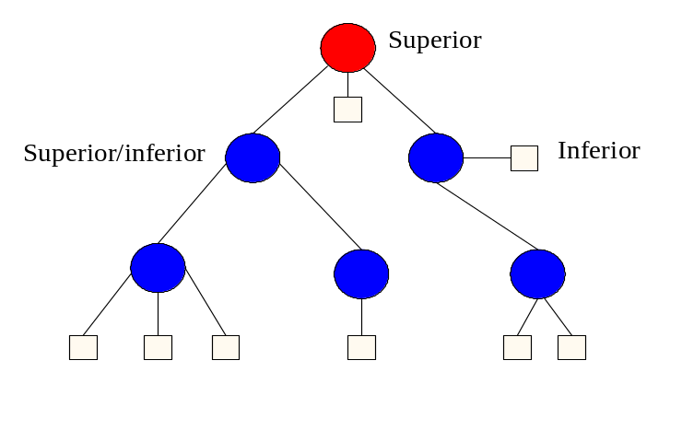
Figure 19: Transaction Relationships

XML configuration
The configuration information required to be associated with an implementation of the BTP interfaces defined in this section is shown below:
<?xml version="1.0" encoding="ISO-8859-1"?>
<jaxtx:transaction-config xmlns:xsi="http://www.w3.org/2001/XMLSchema-instance" xmlns:jaxtx="JAXTX.xsd">
<jaxtx:transaction-protocol>
urn:com:sun:jaxtx:transaction_models:btp:1.0
</jaxtx:transaction-protocol>
</jaxtx:transaction-config>

Client-side interfaces
The classes and interfaces described in this section are located within the javax.jaxtx.model.btp package. The OASIS BTP defines two types of extended transactions:
- Atom: an atom is the typical way in which “transactional” work performed on Web services is scoped. The outcome of an atom is guaranteed to be atomic, such that all enlisted participants will see the same outcome, which will either be to accept (confirm) the work or reject (cancel) it.
- Cohesion: this type of transaction was introduced in order to relax atomicity and allow for the selection of work to be confirmed or cancelled based on higher level business rules. Unlike an atom, a cohesion may give different outcomes to its participants such that some of them may confirm whilst the remainder cancel. In essence, the two-phase protocol for a cohesion is parameterised to allow a user to specify precisely which participants to prepare and which to cancel.
In a traditional transaction system, the application has very few verbs with which to control transactions. Typically these are “begin”, “commit” and “rollback”. When an application asks for a transaction to commit, the coordinator will execute the entire two-phase protocol before returning an outcome (what BTP terms a closed-top commit protocol). The elapse time between the execution of the first phase and the second phase is typically milliseconds to seconds.
BTP allows the time between the two phases to be set by the application by expanding the range of verbs available to include explicit control over both phases, i.e., “prepare”, “confirm” and “cancel”; what BTP terms an open-top completion protocol. The application has complete control over when transactions prepare, and using use whatever business logic is required later determine which transactions to confirm or cancel.
Therefore, although both atoms and cohesions can be terminated in a traditional “closed-top” manner, it is more typical for the two-phase completion protocol to be driven explicitly. When using the basic JAXTX client interfaces (i.e., closed-top termination scheme), the mappings are as follows:
BTP | JAXTX BTP equivalent
“One-shot” cancel termination. | CompletionStatusCancel or CompletionStatusCancelOnly and UserXMLTransaction.end. Successful cancellation returns an Outcome with the name “javax.jaxtx.model.btp.cancel” and completedStatus of CompletionStatusCancel.
“One-shot” confirm termination. | CompletionStatusConfirm and UserXMLTransaction.end. Successful confirmation returns an Outcome with the name “javax.jaxtx.model.btp.confirm” and completedStatus of CompletionStatusCancel. Unsuccessful has CompletionStatusCancel and “javax.jaxtx.model.btp.cancelled”.
Hazard | javax.jaxtx.model.btp.HazardException
Mixed | javax.jaxtx.model.btp.MixedException
Resigned status | javax.jaxtx.model.btp.ResignedStatus
Resigning status | javax.jaxtx.model.btp.ResigningStatus
Prepared status | javax.jaxtx.model.btp.PreparedStatus
Preparing status | javax.jaxtx.model.btp.PreparingStatus
As such, the javax.jaxtx.model.btp.Atom and javax.jaxtx.model.btp.Cohesion exist to extend the default UserXMLTransaction interface.
Instances of the javax.jaxtx.model.btp.Vote interface are returned from the Atom when it is instructed to prepare. An atom and its participants can return one of the following votes as a result:
- VoteCancel: the inferior votes that it has cancelled. The transaction service may inform the inferior of the final decision (hopefully to cancel as well), but it need not.
- VoteConfirm: the inferior votes to confirm. It will typically not have confirmed at this stage but will wait for the transaction outcome. Failure to do so may result in heuristics (contradictions).
- VoteResign: the inferior votes that all of its inferiors have resigned from the transaction. The transaction (atom) is terminated.
When a javax.jaxtx.model.btp.Cohesion is instructed to prepare, cancel or confirm its enlisted participants (inferiors), it may return a status value for each of them. It does this through the javax.jaxtx.model.btp.StatusItem interface. The status is a value from the javax.jaxtx.model.btp.TwoPhaseOutcome enumeration.

Container-side interfaces
The classes and interfaces described in this section are for the optional service-side interactions and are located in the javax.jaxtx.model.btp.opt package.
A BTP superior is represented by an instance of the Superior interface. Each participant within a BTP transaction is represented by the Inferior interface. This has methods for preparing, confirming and cancelling the participant as well as obtaining its current status. As shown previously, a superior may be an inferior in some distributed hierarchy. The root superior is known as the decider and is represented by the Decider interface.
Services can enrol participants through the XMLTransactionManager interface, which returns a reference to the current transaction (Superior) via the getTransaction method. The Transaction interface provides a means whereby Inferiors may be enrolled with a specific transaction. Unlike UserXMLTransaction, a Transaction does represent a specific transaction.
An Inferior is enrolled with a transaction using the enrol method; if the transaction is not in a state where enrolment is possible (e.g., it is terminating) then the javax.jaxtx.exceptions.WrongStateException will be thrown. If the Inferior has already been enrolled with this transaction then the javax.jaxtx.model.btp.DuplicateInferiorException is thrown and the Inferior will not be enrolled with the transaction.
BTP allows for an enrolled Inferior to leave a transaction. This may be accomplished through the resign method. If the coordinator is not in a state where leaving is valid then the javax.jaxtx.exceptions.WrongStateException is thrown. If the Inferior is invalid within the context of the transaction (e.g., it has not been enrolled) then the javax.jaxtx.model.btp.opt.InvalidInferiorException will be thrown.

The J2EE Activity Service
[TBD based on the work on JSR95.]

References
[1] Additional Structuring Mechanisms for the OTS Specification - OMG document orbos/2001-11-08 (http://www.omg.org/cgi-bin/doc?orbos/2001-11-08).
[2] The Web Services Transactions specification, IBM, Microsoft and BEA joint submission,
[3] “Business Transaction Protocol” Furniss, P. (ed). See: http://www.oasis-open.org/committees/business-transactions/#documents

[4] X/Open CAE Specification – Distributed Transaction Processing: The XA Specification, X/Open Document No. XO/CAE/91/300 or ISBN 1 872630 24 3.

Atomic, Consistent, Isolated, Durable.
In order to allow the use of JAXM or JAXRPC do we need to say or do more?
I think we need more defined structure for the URIs.
The J2EE version of the CORBA Activity Service has not bee finalised, though it is close. Rather than base the JAXTX mapping on the CORBA version, which is subtly different, we may need to wait. JAXTXP is heavily influenced by this work, so there may be additional feedback into other parts of the specification.

